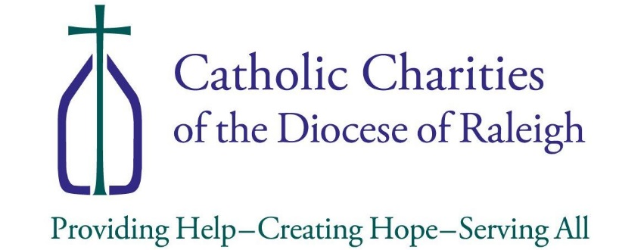

Media Release Form

I, ______________________________, give Catholic Charities
^{Print Name}
permission to use the following items for Catholic Charities brochures, posting online, and other promotional purposes.

(please initial all that apply):

to use any photograph or video taken of myself or my family.
to use my/our name when presenting any information about me/us given during an interview with a Catholic Charities representative.
to without using my/our name use any information about me/us given during an interview with a Catholic Charities representative.

______________________ _______________________
Signature Date

